**JAVA PROGRAMMING**

**ASSIGNMENT-6**

**1.Write a Java program to create a method that reads a file and throws an exception if the file is not found**

import java.io.File;

import java.io.FileNotFoundException;

import java.io.FileReader;

import java.io.BufferedReader;

import java.io.IOException;

public class FileReaderExample {

public static void readFile(String filePath) throws FileNotFoundException, IOException {

File file = new File(filePath);

try (BufferedReader reader = new BufferedReader(new FileReader(file))) {

String line;

while ((line = reader.readLine()) != null) {

System.out.println(line);

}

}

}

public static void main(String[] args) {

String filePath = "example.txt";

try {

readFile(filePath);

} catch (FileNotFoundException e) {

System.out.println("Error: File not found.");

} catch (IOException e) {

System.out.println("Error: An I/O error occurred while reading the file.");

}

}

}

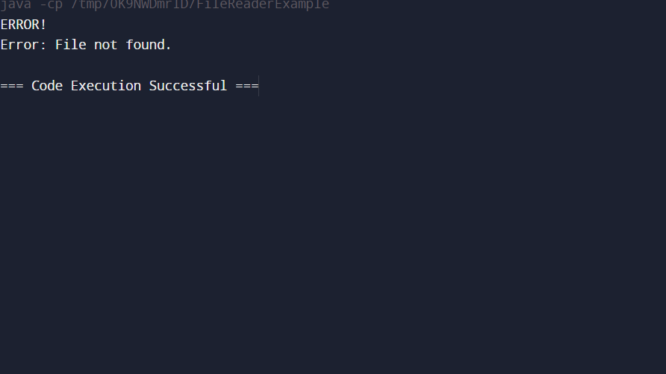

**2.Write a Java program to create a method that reads a file and throws an exception if the file is not found**

import java.io.File;

import java.io.FileNotFoundException;

import java.io.FileReader;

import java.io.BufferedReader;

import java.io.IOException;

public class FileReadExample {

public static void readFile(String filePath) throws FileNotFoundException, IOException {

File file = new File(filePath);

if (!file.exists()) {

throw new FileNotFoundException("File not found: " + filePath);

}

try (BufferedReader reader = new BufferedReader(new FileReader(file))) {

String line;

while ((line = reader.readLine()) != null) {

System.out.println(line);

}

}

}

public static void main(String[] args) {

String filePath = "example.txt";

try {

readFile(filePath);

} catch (FileNotFoundException e) {

System.out.println("Error: File not found.");

System.out.println(e.getMessage());

} catch (IOException e) {

System.out.println("Error: An I/O error occurred while reading the file.");

System.out.println(e.getMessage());

}

}

}

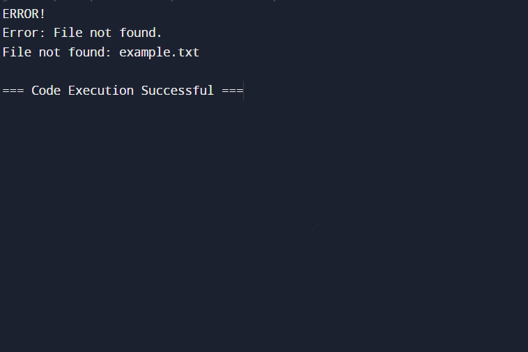

**3.Write a Java program to create a class called Student with private instance variables student_id, student_name, and grades. Provide public getter and setter methods to access and modify the student_id and student_name variables. However, provide a method called addGrade() that allows adding a grade to the grades variable while performing additional validation.**

import java.util.ArrayList;

import java.util.List;

public class Student {

private String student_id;

private String student_name;

private List<Double> grades;

public Student(String student_id, String student_name) {

this.student_id = student_id;

this.student_name = student_name;

this.grades = new ArrayList<>();

}

public String getStudentId() {

return student_id;

}

public void setStudentId(String student_id) {

this.student_id = student_id;

}

public String getStudentName() {

return student_name;

}

public void setStudentName(String student_name) {

this.student_name = student_name;

}

public void addGrade(double grade) {

if (grade < 0.0 || grade > 100.0) {

System.out.println("Error: Grade must be between 0 and 100.");

} else {

grades.add(grade);

System.out.println("Grade added: " + grade);

}

}

public void displayGrades() {

System.out.println("Grades for " + student_name + ": " + grades);

}

public static void main(String[] args) {

Student student = new Student("S12345", "John Doe");

student.setStudentId("S67890");

student.setStudentName("Jane Doe");

System.out.println("Student ID: " + student.getStudentId());

System.out.println("Student Name: " + student.getStudentName());

student.addGrade(95.0);

student.addGrade(105.0);

student.addGrade(-10.0);

student.displayGrades();

}

}

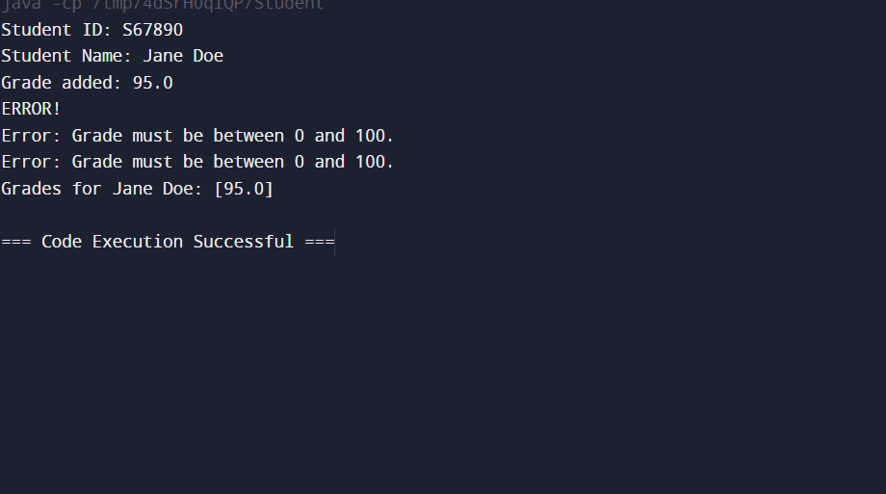

**4.Write a JavaFX application with a text input field and a button. When the button is clicked, display the text entered in the input field in a label**.

import javafx.application.Application;

import javafx.geometry.Insets;

import javafx.scene.Scene;

import javafx.scene.control.Button;

import javafx.scene.control.Label;

import javafx.scene.control.TextField;

import javafx.scene.layout.VBox;

import javafx.stage.Stage;

public class TextDisplayApp extends Application {

@Override

public void start(Stage primaryStage) {

TextField textField = new TextField();

textField.setPromptText("Enter some text");

Label displayLabel = new Label();

Button showButton = new Button("Show Text");

showButton.setOnAction(e -> {

String text = textField.getText();

displayLabel.setText(text);

});

VBox vbox = new VBox(10);

vbox.setPadding(new Insets(20));

vbox.getChildren().addAll(textField, showButton, displayLabel);

Scene scene = new Scene(vbox, 300, 200);

primaryStage.setTitle("Text Display Application");

primaryStage.setScene(scene);

primaryStage.show();

}

public static void main(String[] args) {

launch(args);

}

}